Vol. 3 – No. 69 – Tonga April 30th, 2026 Baha’i’s of Tonga
. . . . . . . . . . . . . . . . . . . . . . . . . . . . . . . . . . . . . . . . . . . . . . . . . . . . . . . . . . . . . . . . . . . . . . . . . . . . . . . . . . . . . . . . . . . . . . . . . . . . . . . . . . . . . . . . . . . . . . . . . . . . . . . . . . . . . . . . . . . . . . . . . . . . . . . . . . . . . . . . . . . . . . . . . . . . . . . . . . . . . . . . . . . . . . . . . . . . . . . . . . . . . . . . . . . . . . . . . .
The Monthly Bugle

"Blessed are they who follow the Light in their youthful days..."
Editorial Board:
Youth Media team

. . . . . . . . . . . . . . . . . . . . . . . . . . . . . . . . . . . . . . . . . . . . . . . . . . . . . . . . . . . . . . . . . . . . . . . . . . . . . . . . . . . . . . . . . . . . . . . . . . . . . . . . . . . . . . . . . . . . . . . . . . . . . . . . . . . . . . . . . . . . . . . . . . . . . . . . . . . . . . . . . . . . . . . . . . . . . . . . . . . . . . . . . . . . . . . . . . . . . . . . . . . . . . . . . . . . . . . . . .

Have You Heard The Latest Good News?


Bambi
al.moeaki@gmail.com

Feasts & Holy Days Timeline

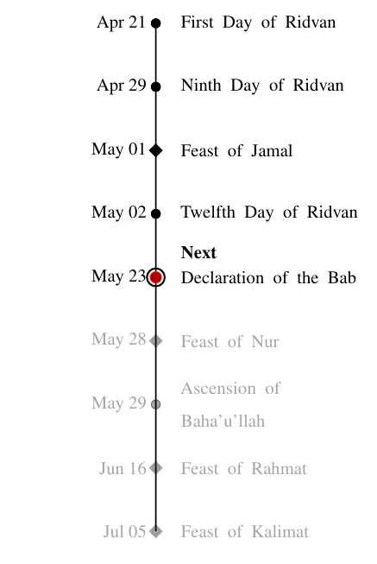

Figure 1: Upcoming Baha’i Feasts and Holy Days

idvan, the most sacred Baha’i fes- tival, commemorates the period
R
in 1863 when Baha’u’llah declared His mission as a Manifestation of God. Celebrated over 12 days, Baha’is around the world gather for prayer, re- flection, and community events with observances on the 1st, 9th, and 12th days. This festival also includes the election of Local and National Spiri- tual Assemblies, held in a spirit of joy, unity, and devotion.

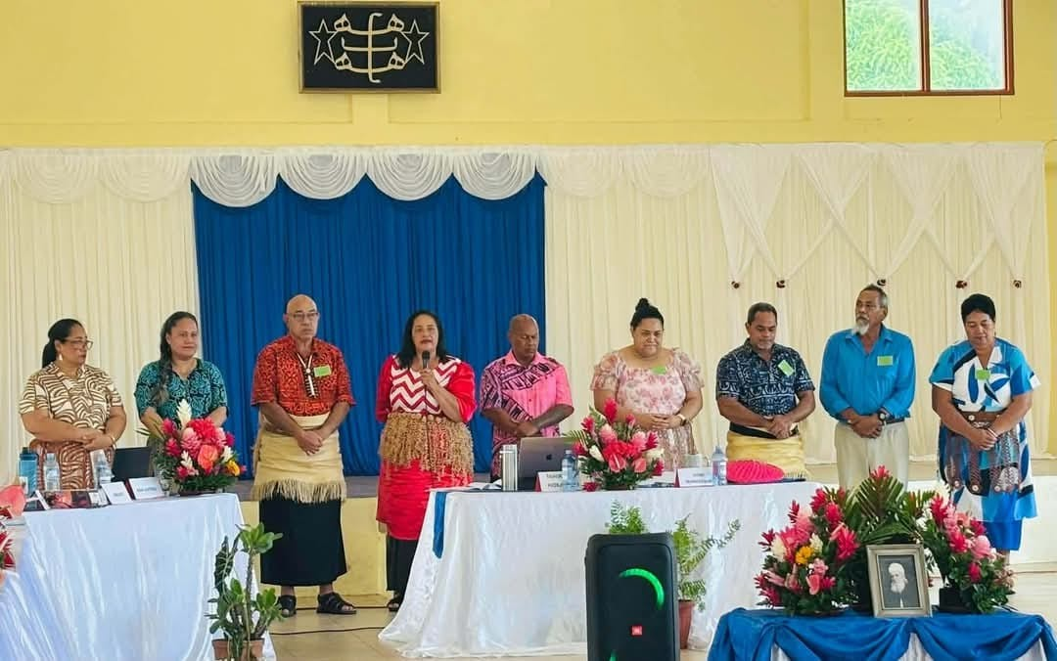
Unit Convention

Figure 2: Newly elected NSA members 2026

Over the course of 3 days, Baha’is
gathered to reflect on community affairs, reflect on messages and guidance from the Universal House of Justice (UHJ), and ultimately, appointing 9 new members of the National Spiritual Assembly (NSA) to serve over the next four (4) years. The members are:
- member 1
- Member 2
- Member 3
- Member 4
- Member 5
- Member 6
- Member 7
- Member 8
- Member 9

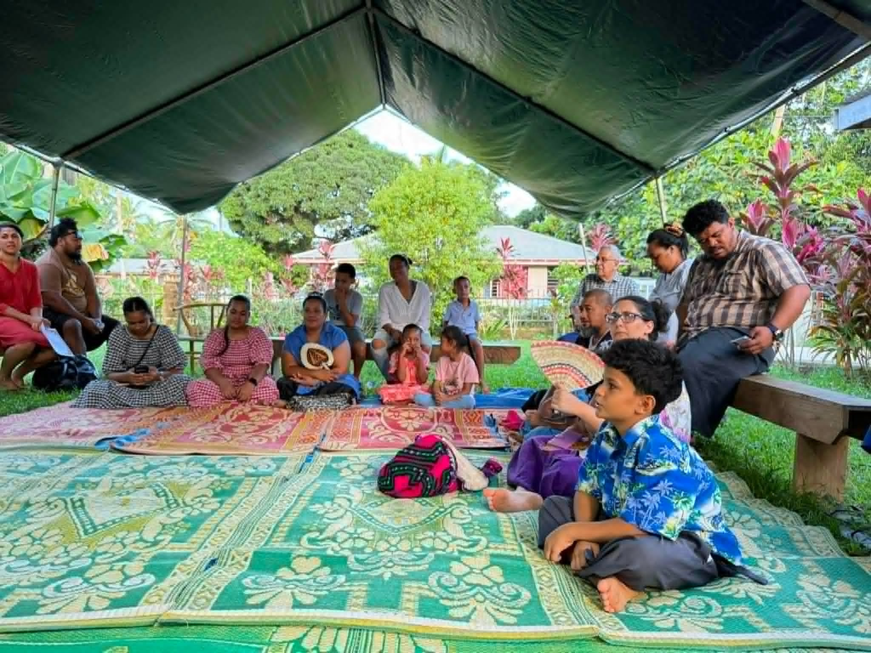
Feast of Jamal / Ridvan
Figure 3: Devotion at Tofoa Community

(Decription xy)

Gate to Glory and Greatness
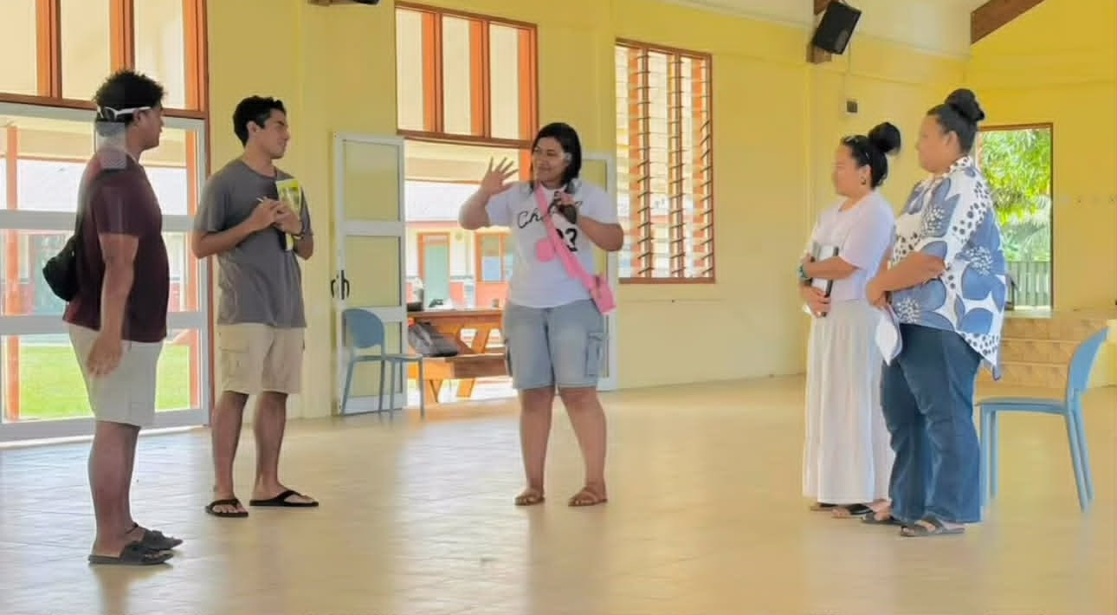
Figure 4: Sharing a Prayer

A nation-wide camp was conducted over 5 days, devoted to a focused study of Book 7 (’Walking a Path of Ser vice’) with the intention to strengthen the capacity of the friends in tutoring Book 1. Core principles nurtured the warmth of simply sharing a prayer, of creating spaces that nurtured an advancement of understanding, and over all, a shift in perspective to contribute this spiritual solution as something that is not just for Baha’is, but for ev eryone. Following this camp, 20+ new tutors set out with renewed energy and enthusiasm, leading elevated conver sations within their families, schools, and within their institutions.

Saturday Devotions

Youth
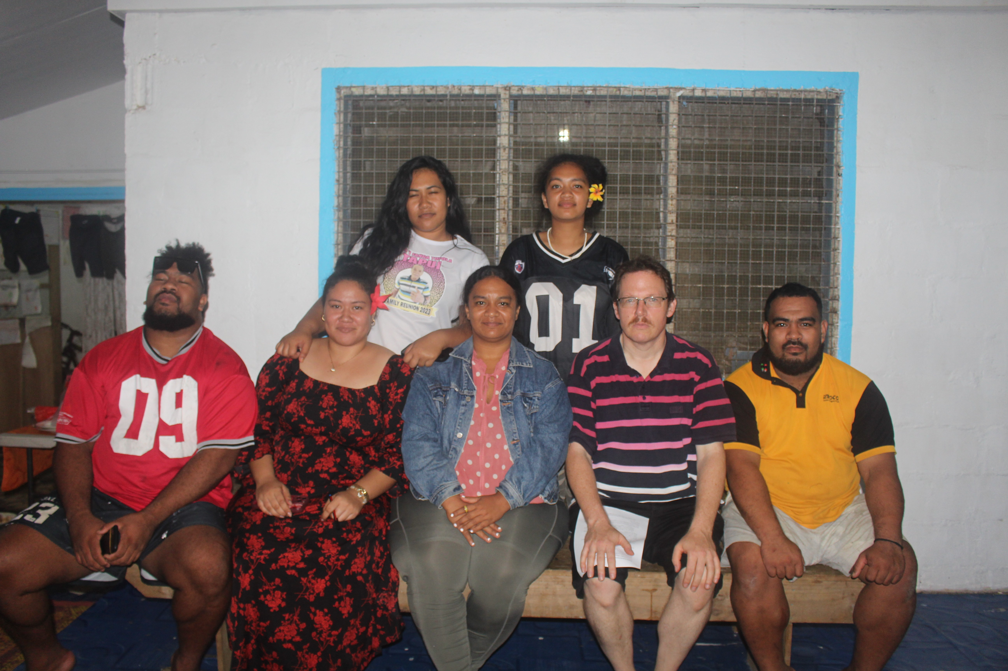
Dinner & Deepening
Figure 5: Post dinner & Deepening

The youth continue to engage in weekly deepenings covering a wide range of spiritual topics, which include spiritual trials, the sacred duty of voting, conversations exploring marriage, equality of men and women, economic spirituality, the Seven Valleys- and many others. The aim is to deepen the knowledge of the youth and to build capacity to expound of core principles of the Faith so relevant to every day life.

Zumba at 6am
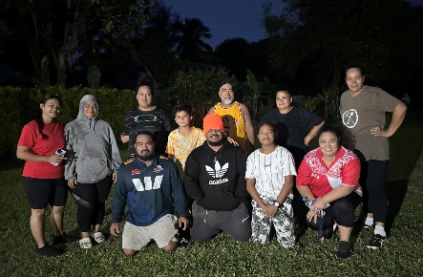

Figure 6: Morning exercise

Morning Zumba sessions have started in promotion of a healthy and active lifestyle. These will be running at 6:00-6:30am every Monday and Wednesday at the Pongi residence.

Youth night (Saturdays @ Mercy)
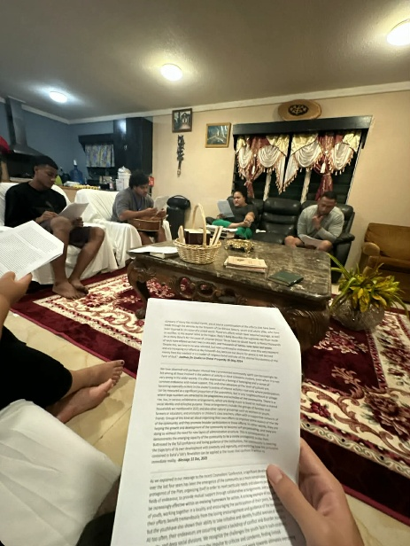

Figure 6: Youth deepening

Junior Youth

Figure 6: JY photo

(Description xy)


Childrens Class

Figure 7: Children Class photo

(Description xyz)

Upcoming Events:

